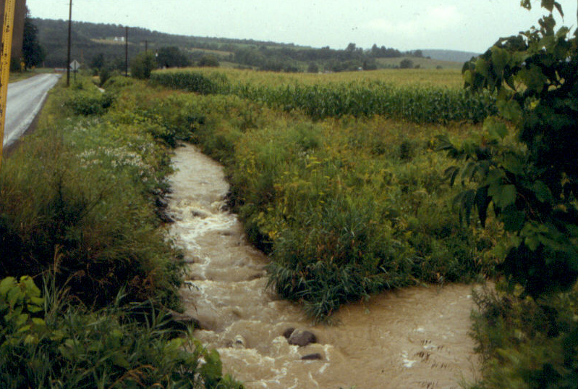Roadside Ditch Curriculum Module
(a.k.a. Altered Watershed Drainage Networks)

Rebecca Schneider, Assoc. Professor,
Dept. Natural Resources
Nancy Trautmann, Senior Extension Associate,
Dept. Natural Resources
Linda Wagenet, Senior Extension Associate,
Dept. Development Sociology

Project Goals:
1. To increase awareness of the hydrologic linkages between watershed land use and stream ecosystem health.
2. To map the connections between impervious surfaces, roadside ditches, and nearby streams.
3. To become familiar with Global Positioning System technology;
4. (advanced) To quantify sediment loads transported by ditches into streams.

Activity Steps:
Part A.
1. Set up background context using Roadside Ditch Powerpoint presentation.
Part B.
2. Obtain U.S. Geological Survey topographic quadrangle for your
school and surroundings (1: 24,000 scale).

[If needed, explain how to interpret contour intervals,
scale, impermanent versus permanent stream channel system,
roads, other symbols. ]

2. Locate the school and highlight any parking lots or other impervious surfaces.

3. Point out and have students highlight with markers the stream channel network and the watershed divide.
[see handouts for how to identify stream order
and watershed divide.]

4. Have students highlight the road network in a different color marker and note intersections with the stream channels.

5. Explain Global Positioning System technology - portable, hand-held units.
- The basis of GPS is "triangulation" from satellites.
- To "triangulate," a GPS receiver measures distance using the travel time of radio signals.
- To measure travel time, GPS needs very accurate timing which it achieves with some tricks.
- Along with distance, you need to know exactly where the satellites are in space. High orbits and careful monitoring are the secret.
- You must correct for any delays the signal experiences as it travels through the atmosphere.
- Finally, you can now obtain the precise time and location from the GPS satellites.
http://www.beaglesoft.com/gpstechnology.htm

6. Organize students in teams of 2-3 students and have them
walk downslope along a ditch towards the stream.

CONSIDER ISSUES OF SAFETY FOR STUDENTS WORKING
THIS CLOSE TO THE ROADWAY!

Using the GPS Unit, stop whenever the ditch does any of the following:
- Empties directly into a stream
- Empties into a storm drain
- Comes to a dead end
- Empties into wetland or pond
- Drains into a catchment basin
- Drains onto a lawn
- Joins another ditch or goes into a culvert
- Shows some other change in direction or type of flow

7. At each of these stopping points, have the students use the GPS unit to
obtain the latitude and longitude. This can be recorded directly into the GPS unit, along with the ditch connection type, or recorded on the attached data sheet. Along the way, have them note the conditions of the substrate within each section of ditch:
- Weedy
- Mowed grass
- Bare soil
- Concrete or tar
- Rock lined
- Into ditch or culvert
- other___

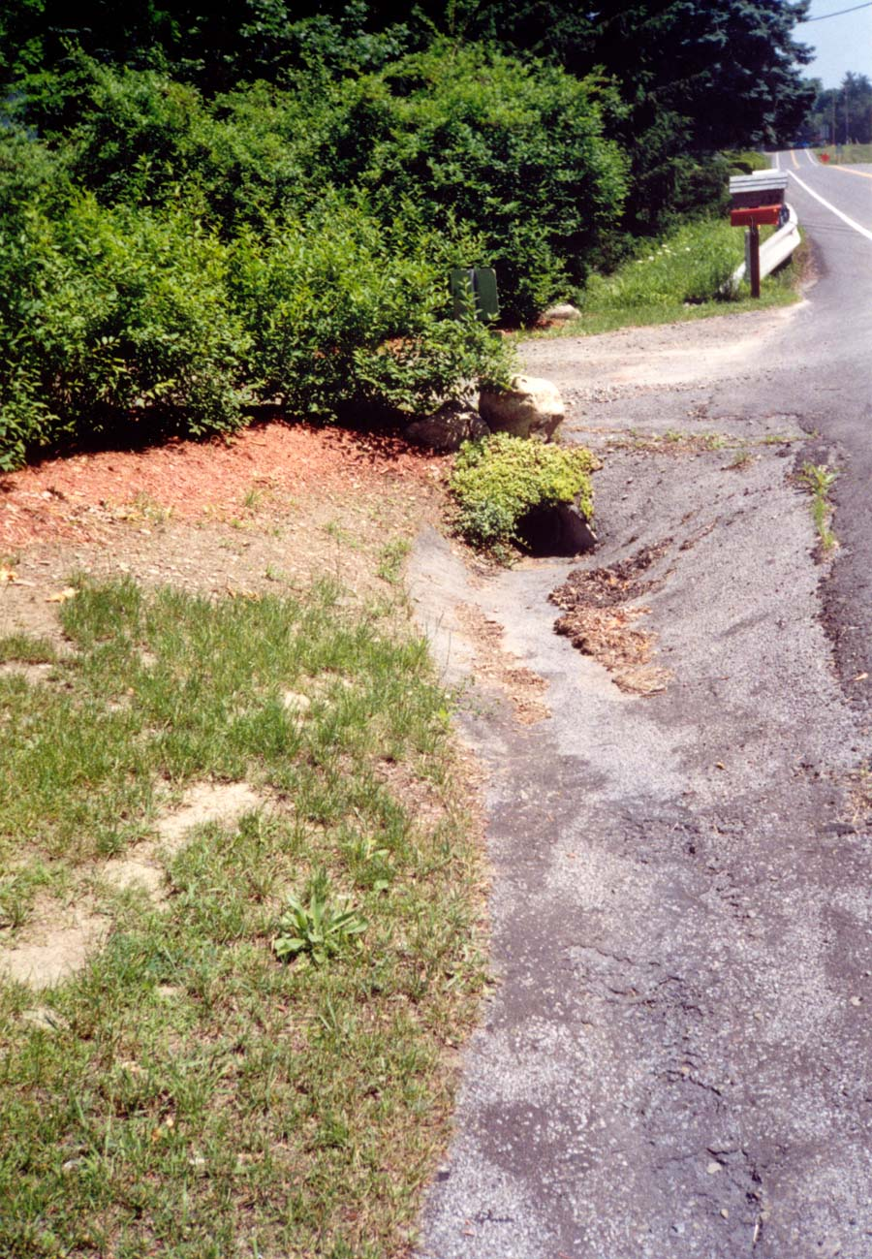
Paved ditch connected to stream by culvert

Option #1: Along the way, have them record the different types of land use activities that adjoin their ditch in their notes:
- lawn,
- sidewalk,
- houses,
- fields,
- parking lot,
- businesses

8. Upon their return, have each team record their findings on the master topographic map.
- Create a color code for the different types of ditch connections.
- If desired, have them note the land uses and ditch conditions on the master map.
- If desired, students can measure and compare the length of the natural stream channel with that of the connected ditch system (using a rolling planimeter).

9. Discussion Points:

- How much has their stream drainage system been altered by the artificial drainage from ditches?
- What types of land uses do the ditches connect to the streams?
- Where in the stream channel network (1st order, impermanent, etc.) do their ditches connect?
- What types of substrate conditions did they find within the ditches and what are the implications for transport into the stream?

Part C. Estimating Sediment Bedload Transport

10. Identify one or more ditches for monitoring - if desired, comparisons can be made among ditches that differ in substrate type or adjacent land use. OBTAIN PERMISSION FROM THE APPROPRIATE ROADS DEPARTMENT (TOWN, COUNTY).

11. Dig a small pit (the size of the bucket) in the bottom of the ditch, just before the ditch discharges into a stream.

12. Insert the bucket sleeve into the pit and anchor. Mark w/ a small flag - they easily become buried and hard to relocate.

13. Insert the bedload pit trap into the sleeve, with the handle facing downstream. There should be very little lip protruding from the ground surface, otherwise it will interfere with trapping.

14. Monitor the trap after each rainfall event. Remove the bucket and its contents. If desired, hand sort the contents into several categories: human artifacts (litter), organic material (such as worms, insects, leaves) and mineral material (rocks, gravel, sand). The contents will then be spread on aluminum pie tins and heated in a conventional oven at 100 deg. F for 2-3 hours or until dry. Weigh the contents to the nearest 0.5 grams (do not include the weight of the pie tins).

14. Discussion Points:
- What kind of materials does the ditch transport into the stream? If desired, have them compare the types using a histogram or pie chart.
- What factors seem to control the amount of bedload moving through the ditch?
- Extrapolate from their ditch to the entire ditch network to estimate the total bedloads being transported from ditches into the stream system.
- What would they recommend concerning better types of management for maintaining roadside ditches?
Roadside Ditch Field Data Sheet

You can enter this data on the NYS Ditch Website. For instructions, see http://ei.cornell.edu/watersheds/ditches/Ditch_11.asp

Name(s): ________________________________________________________________ Date: _________________

Road Name: ____________________________________________________________

Topographic Quadrangle Name: ________________________________________

School and Teacher Name: ______________________________________________

Site # :  Site Name or Description: | Ditch  Latitude  from:  42, ___Min, ___Sec  to:  42, ___Min, ___Sec | Ditch  Longitude  from:  -76, ___Min, ___Sec  to:  -76, ___Min, ___Sec | Ditch connection type:  ◻ direct to stream  ◻ into storm drain  ◻ dead end  ◻ into wetland or pond  ◻ into catchment basin  ◻ onto lawn  ◻ into ditch or culvert  ◻ other ____________ | Ditch condition:  ◻ weedy  ◻ mowed grass  ◻ bare soil  ◻ concrete or tar  ◻ rock lined  ◻ into ditch or culvert  ◻ other___________ | Notes on land use adjacent to ditch:
Site # :  Site Name or Description: | Ditch  Latitude  from:  42, ___Min, ___Sec  to:  42, ___Min, ___Sec | Ditch  Longitude  from:  -76, ___Min, ___Sec  to:  -76, ___Min, ___Sec | Ditch connection type:  ◻ direct to stream  ◻ into storm drain  ◻ dead end  ◻ into wetland or pond  ◻ into catchment basin  ◻ onto lawn  ◻ into ditch or culvert  ◻ other ____________ | Ditch condition:  ◻ weedy  ◻ mowed grass  ◻ bare soil  ◻ concrete or tar  ◻ rock lined  ◻ into ditch or culvert  ◻ other___________ | Notes on land use adjacent to ditch:

Cornell University, Roadside Ditch Project http://ei.cornell.edu/watersheds/ditches/default.asp

Site # :  Site Name or Description: | Ditch  Latitude  from:  42, ___Min, ___Sec  to:  42, ___Min, ___Sec | Ditch  Longitude  from:  -76, ___Min, ___Sec  to:  -76, ___Min, ___Sec | Ditch connection type:  ◻ direct to stream  ◻ into storm drain  ◻ dead end  ◻ into wetland or pond  ◻ into catchment basin  ◻ onto lawn  ◻ into ditch or culvert  ◻ other ____________ | Ditch condition:  ◻ weedy  ◻ mowed grass  ◻ bare soil  ◻ concrete or tar  ◻ rock lined  ◻ into ditch or culvert  ◻ other___________ | Notes on land use adjacent to ditch:
Site # :  Site Name or Description: | Ditch  Latitude  from:  42, ___Min, ___Sec  to:  42, ___Min, ___Sec | Ditch  Longitude  from:  -76, ___Min, ___Sec  to:  -76, ___Min, ___Sec | Ditch connection type:  ◻ direct to stream  ◻ into storm drain  ◻ dead end  ◻ into wetland or pond  ◻ into catchment basin  ◻ onto lawn  ◻ into ditch or culvert  ◻ other ____________ | Ditch condition:  ◻ weedy  ◻ mowed grass  ◻ bare soil  ◻ concrete or tar  ◻ rock lined  ◻ into ditch or culvert  ◻ other___________ | Notes on land use adjacent to ditch:
Site # :  Site Name or Description: | Ditch  Latitude  from:  42, ___Min, ___Sec  to:  42, ___Min, ___Sec | Ditch  Longitude  from:  -76, ___Min, ___Sec  to:  -76, ___Min, ___Sec | Ditch connection type:  ◻ direct to stream  ◻ into storm drain  ◻ dead end  ◻ into wetland or pond  ◻ into catchment basin  ◻ onto lawn  ◻ into ditch or culvert  ◻ other ____________ | Ditch condition:  ◻ weedy  ◻ mowed grass  ◻ bare soil  ◻ concrete or tar  ◻ rock lined  ◻ into ditch or culvert  ◻ other___________ | Notes on land use adjacent to ditch:

Cornell University, Roadside Ditch Project http://ei.cornell.edu/watersheds/ditches/default.asp

